**Current ZIllidex.com Walk Through**

At login using my username and password provided this is the first page that comes up:

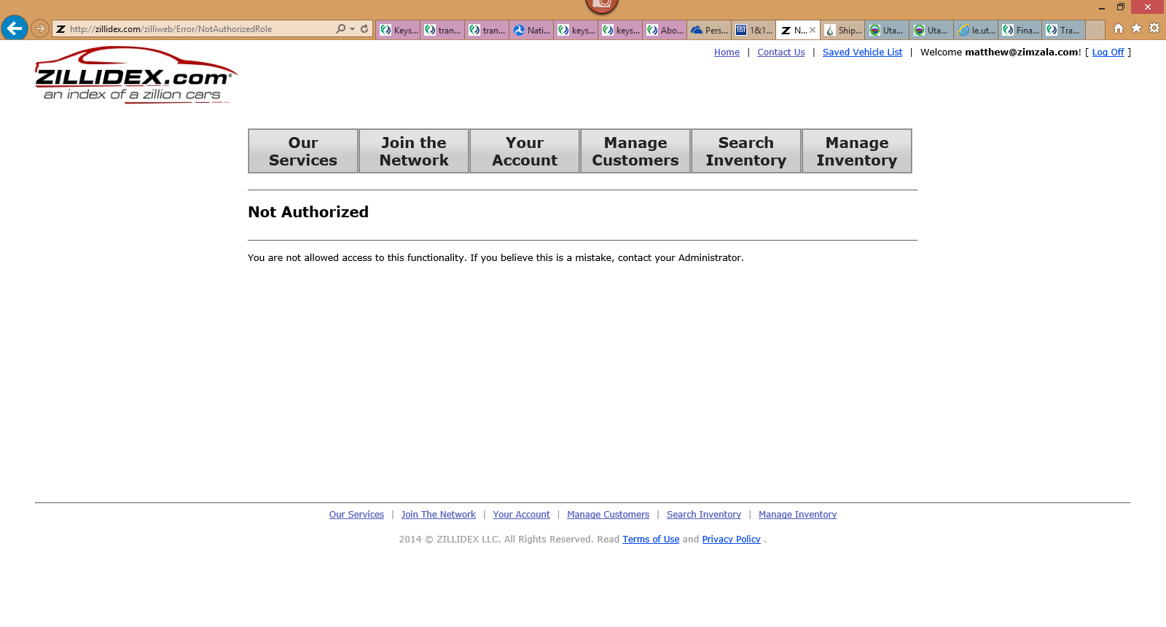

It will allow me to navigate to the other tabs from here but obviously needs to be corrected to a welcome screen with Greeting and Instructions as seen in previous documentation of first site as seen below as the first step should be to setup or “Join the Network”:

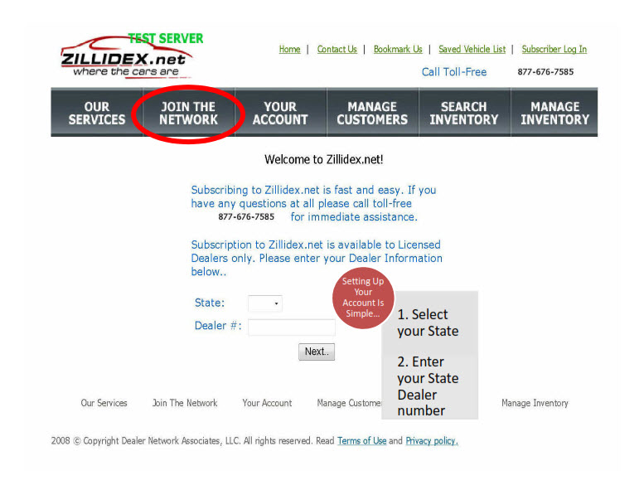

**Our Services Screen:**

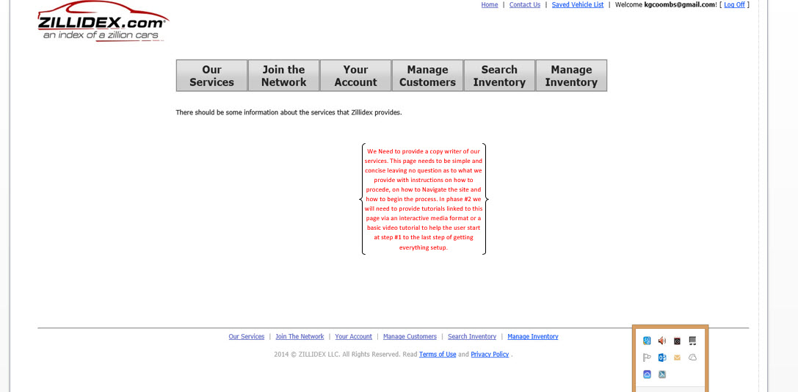

**Join Our Network**

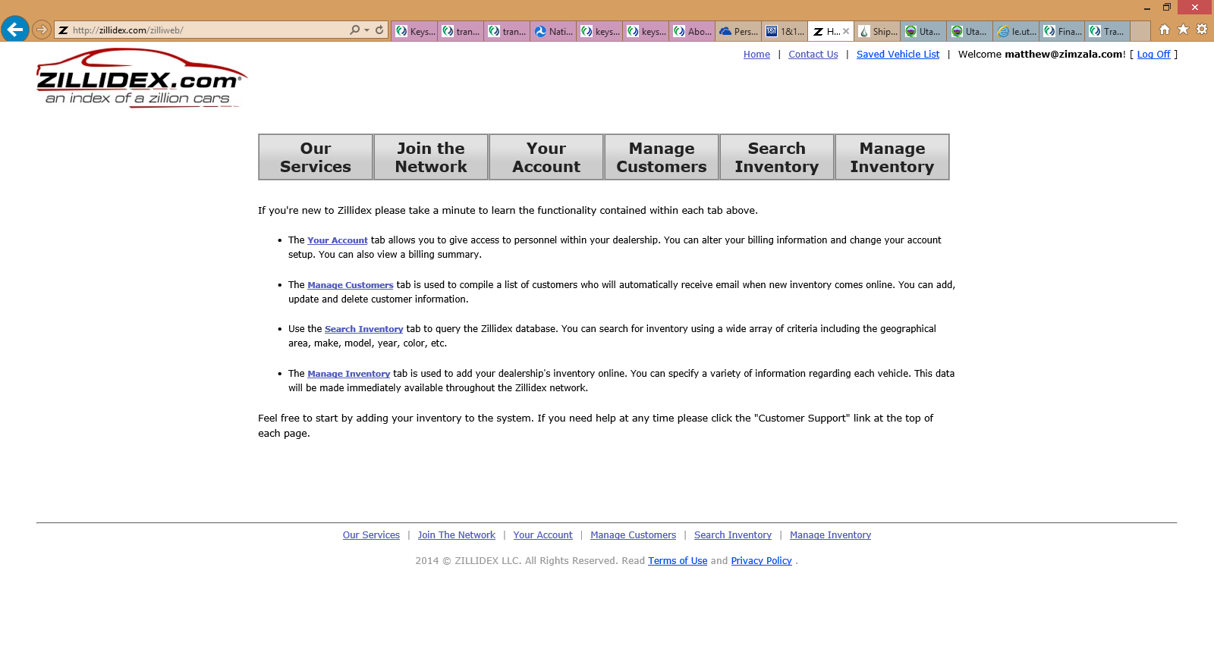

1. When clicking on first bullet point “Your Account” it takes you back to the same error page as before:

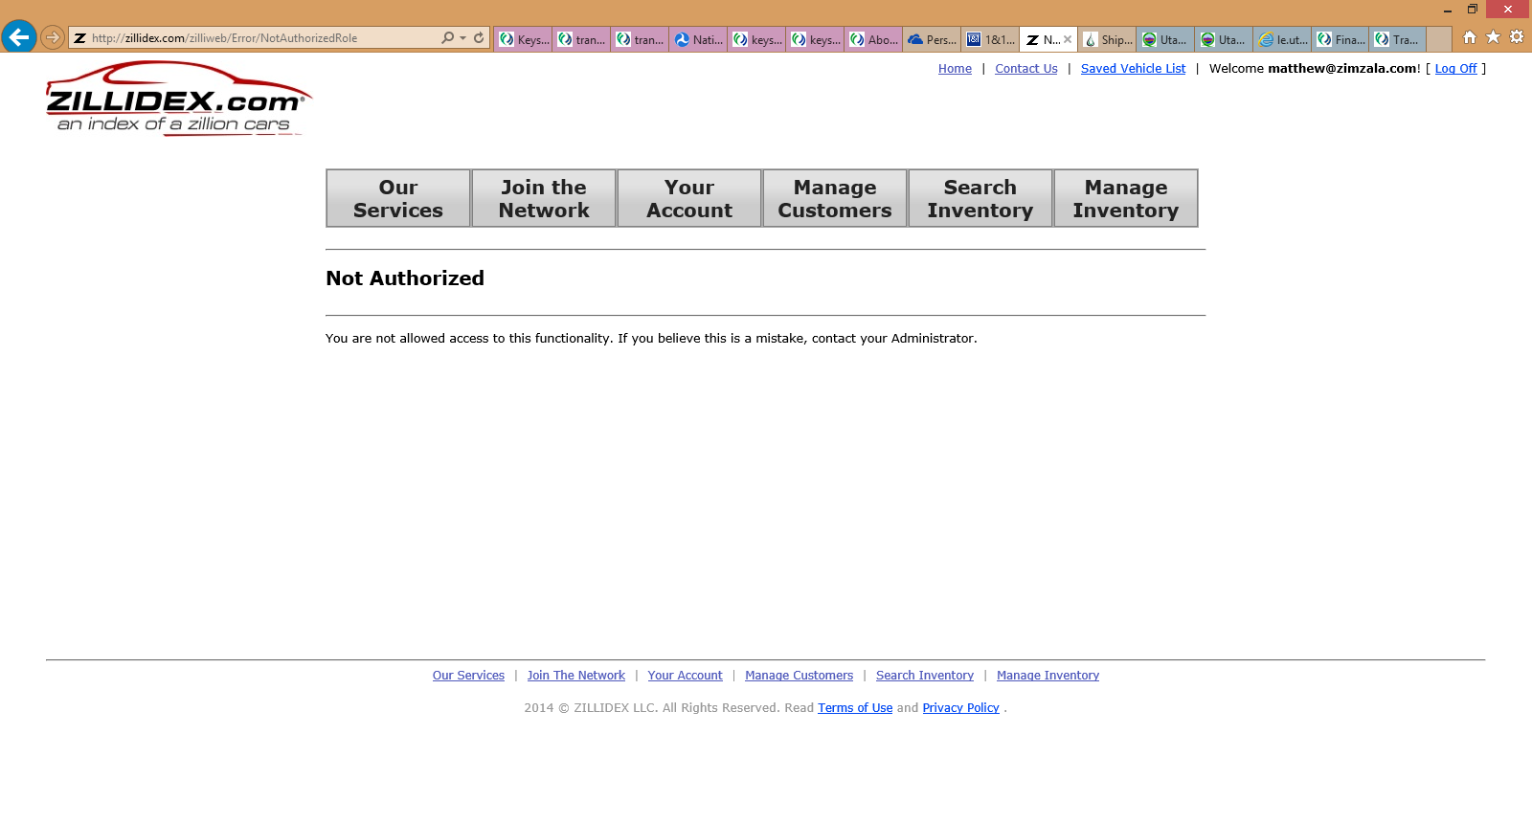

**Manage Customers:**

1. Created a new customer and everything clicked save, At which point it brought me back to the Customer list page but my save customer was not displayed. While setting up this customer I had “Low Book Sales” selected in the dealer drop down at the top. After going through searching and trying to find the customer I switched the Dealer to “Ed Kenley Ford, INC. and my customer I just added under the Low book sales account showed up under Ed Kenley. **Where are we at with a visual database diagram in Visio or Visual format with relationships, naming conventions, Indexing, etc... I would be more than happy to walk through it to see if I can be of any help….** 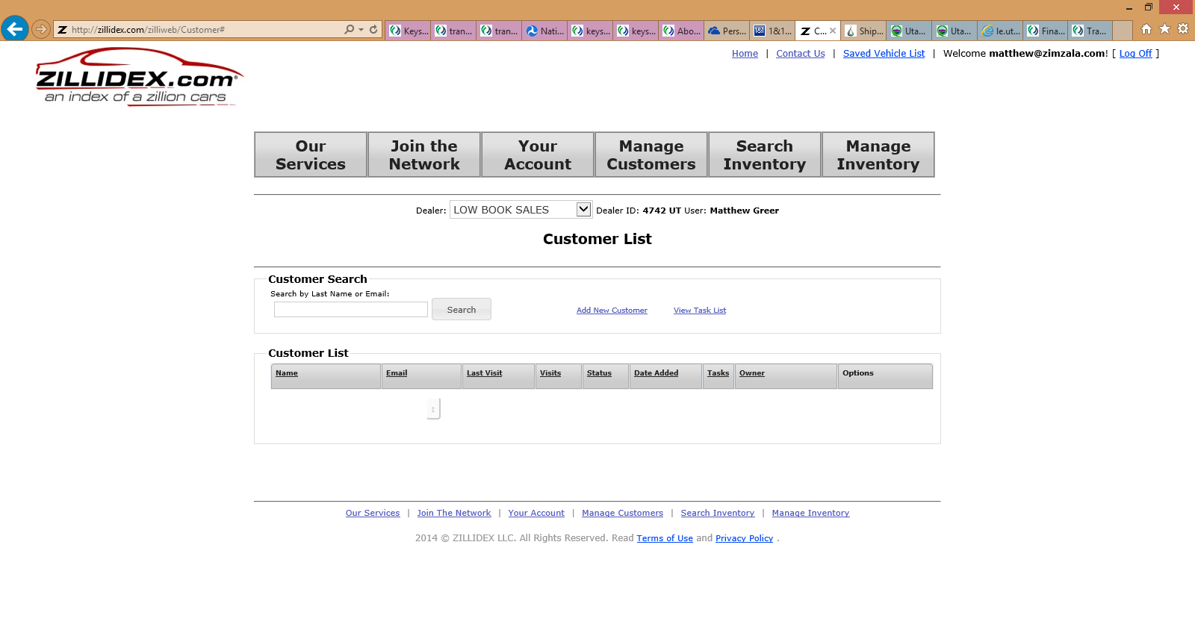

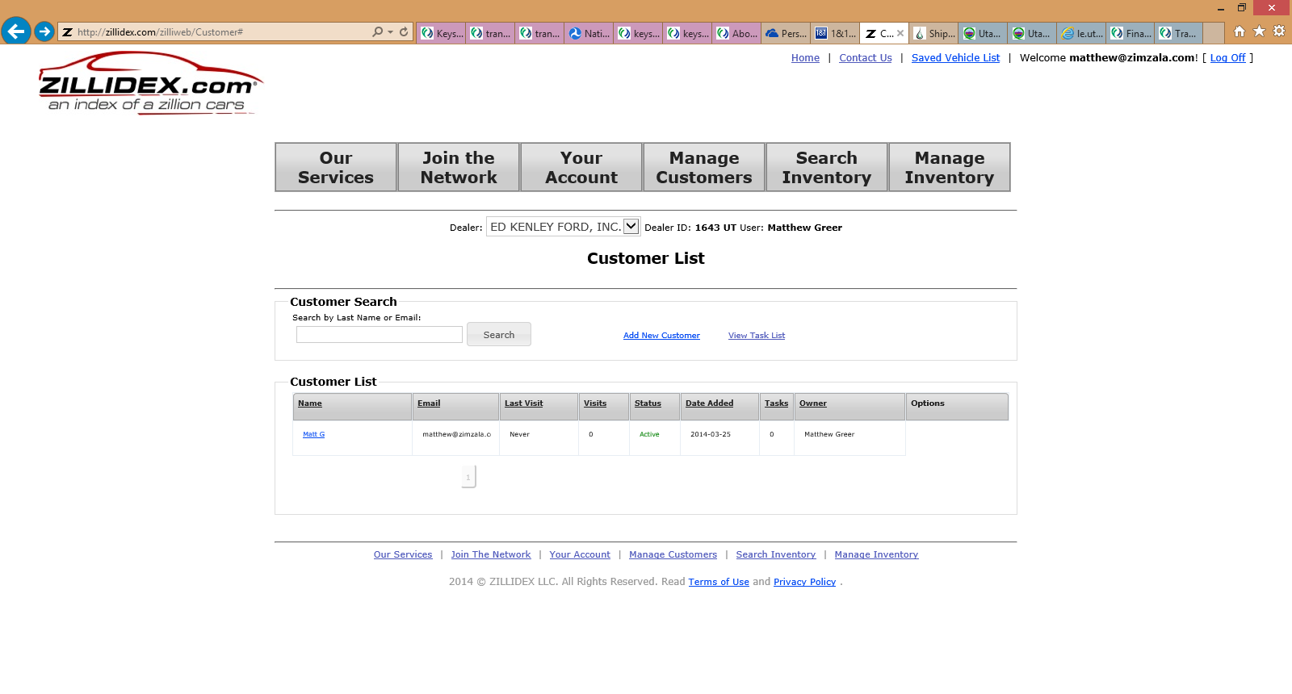

1. When then clicking on the customer that was saved I am taken back to this screen:

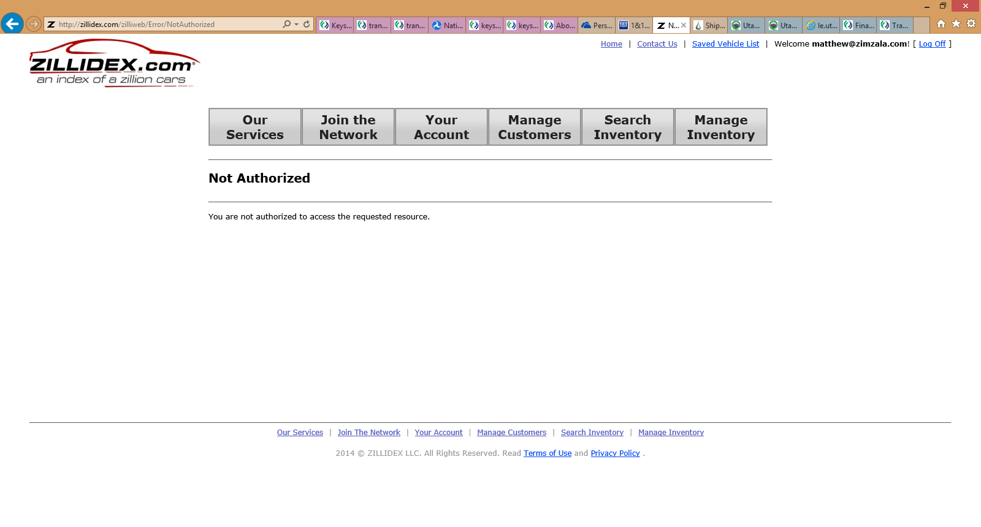

**Inventory search**

1. If I add any search criteria to any of the options provided in the Search Inventory screen I get the following screen display I.E. “Search Area” 500 Miles from zipcode (84020) as seen below:

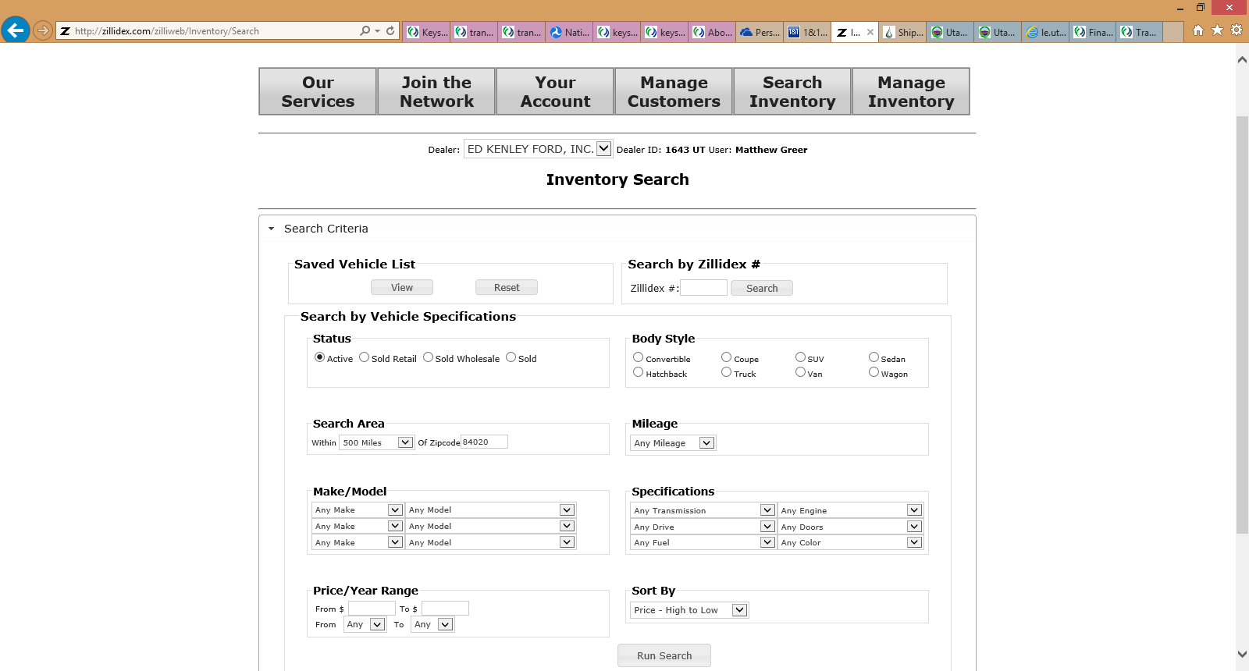

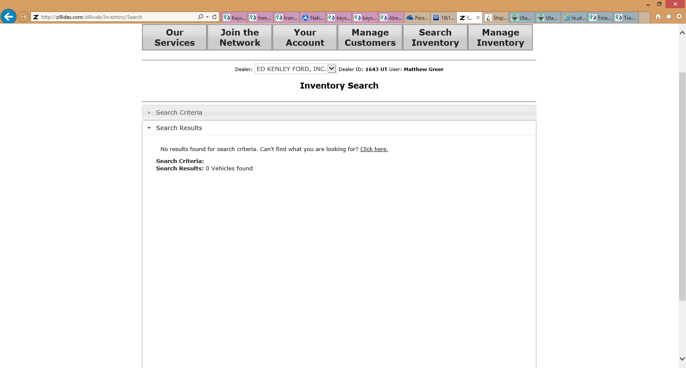

1. If I leave all search criteria blank I receive the following while searching under Dealer Ed Kenly: All 257 vehicles I am only left to assume that this is what they have setup.
   1. We need to provide a filter criteria on this page to refine search i.e. Price High to Low, Year, Model, etc…

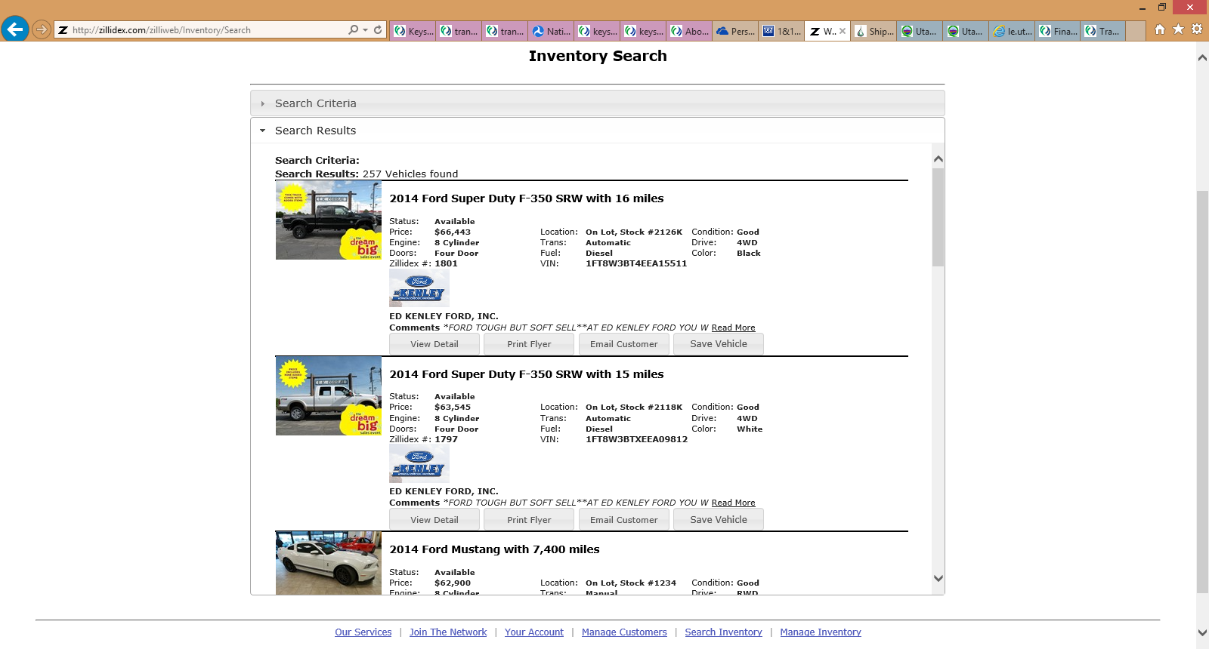

1. When Switching dealers to Low Book Sales back on the search screen and clicking search I am again presented with all of Ed Kenly’s Vehicles as well as Low book Sales Inventory at the back pages:

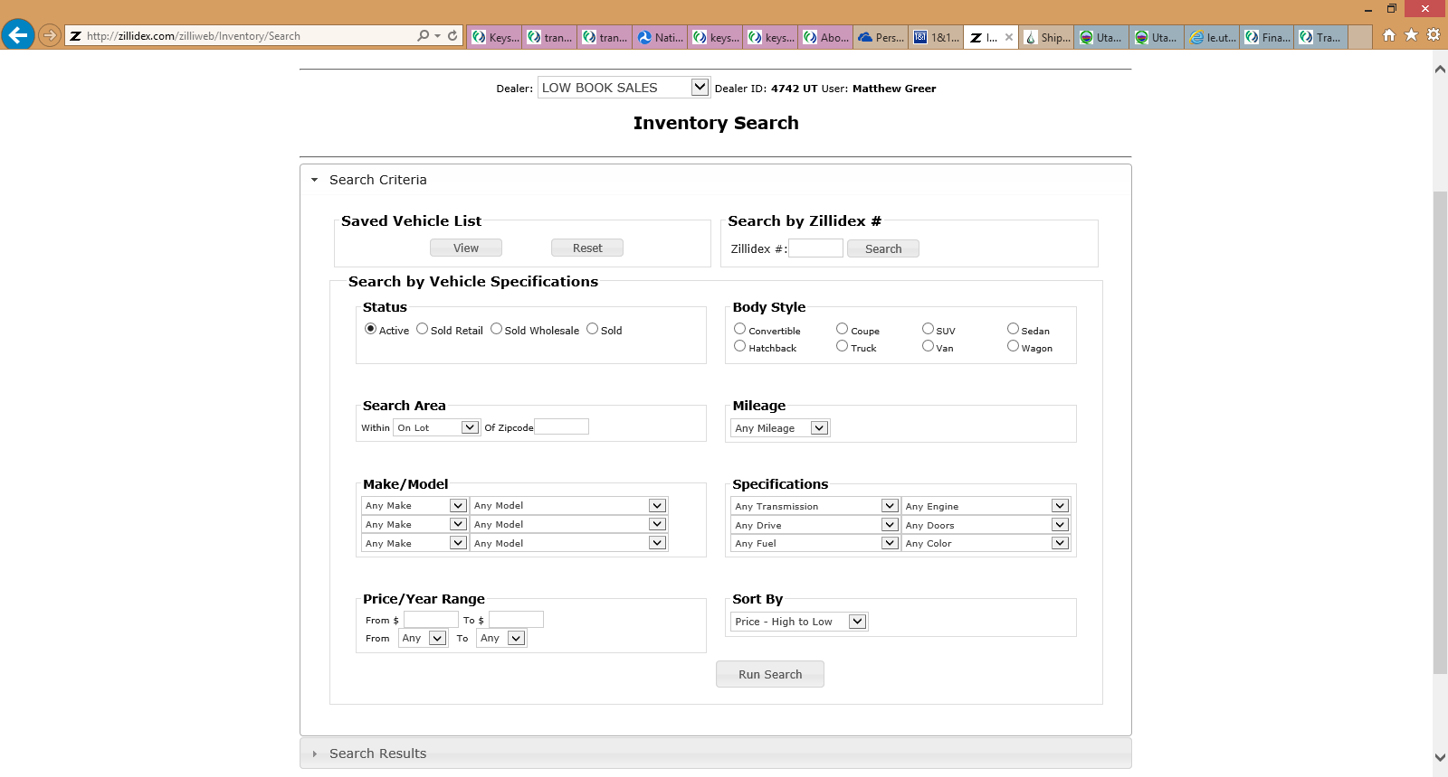

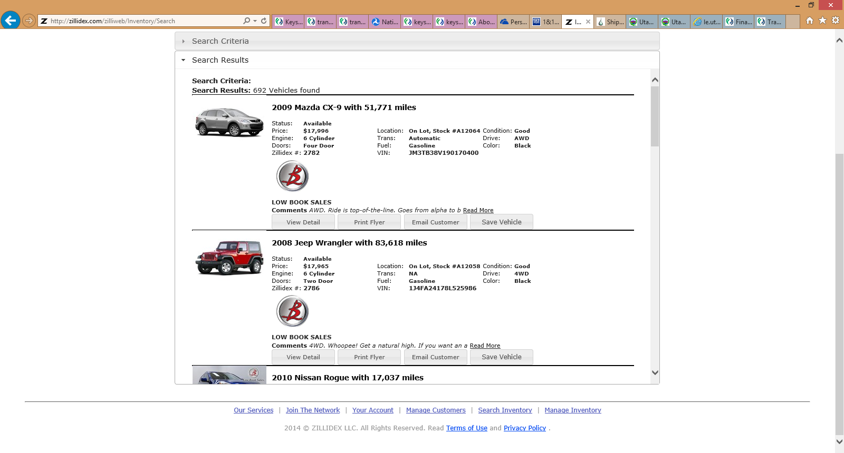

1. Inventory Detail: While clicking into a random vehicle I receive the following page view:

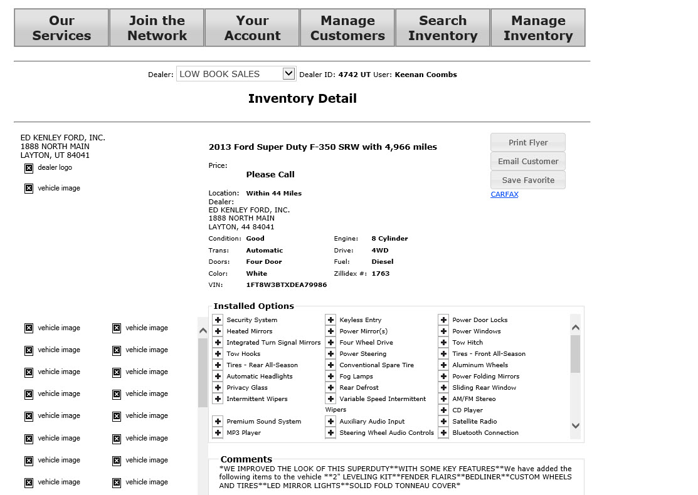

* 1. Dealer Logos are not showing
  2. No Vehicle image while it was on the last page
  3. No additional Vehicle images, which is most likely due to none being loaded. If that is the case we need to condense or remove the left side and state “There are no other images for display”
  4. When Clicking on the “Print Flyer” button top right side I was presented with the following error:

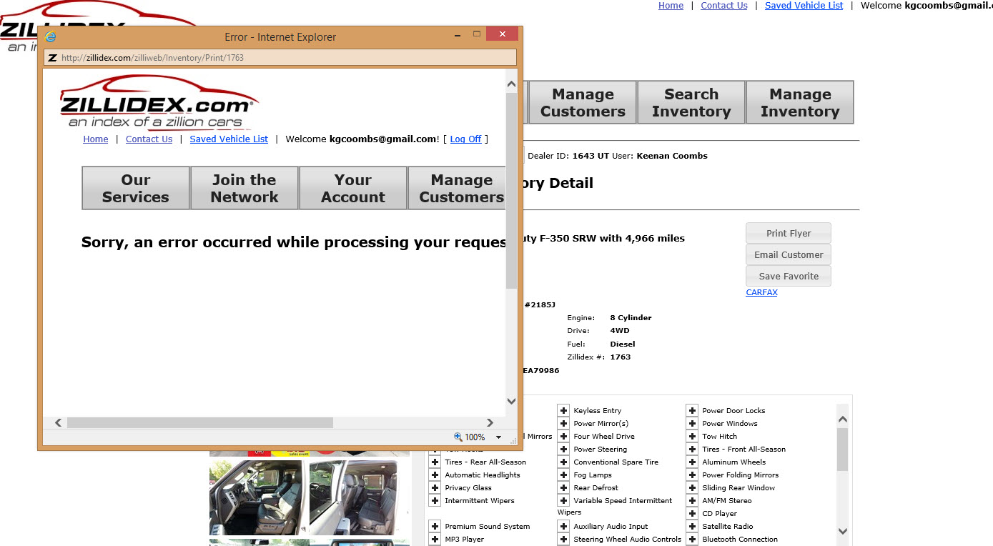

* 1. When clicking on the “Email Customer” Button I was presented with the following error:

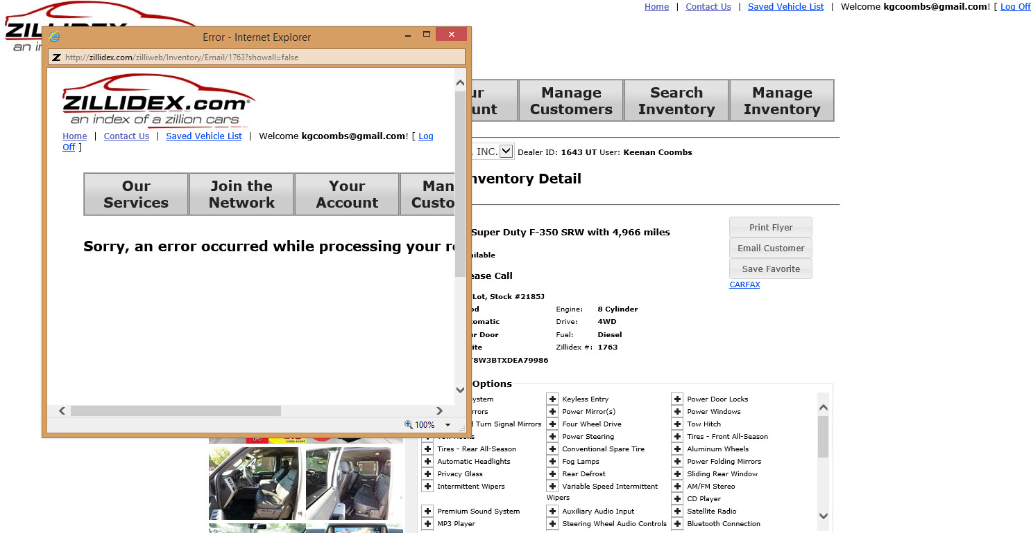

1. After trying to navigate back to multiple pages I just started receiving the following “Runtime Error”

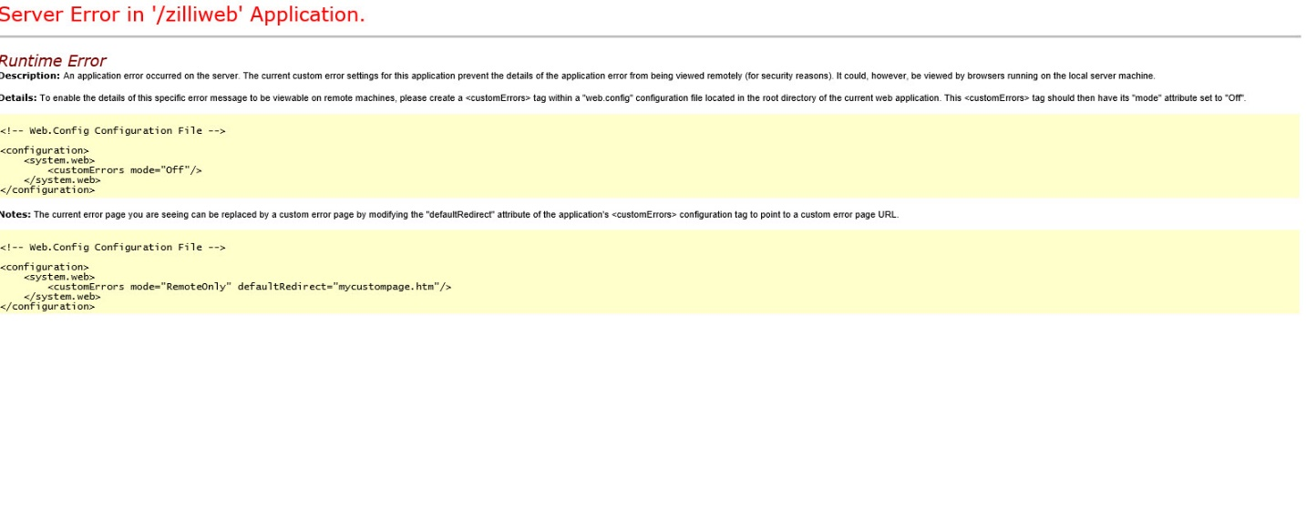

I can list all the Web.Config. files that I received this on, but once it started it was almost continueous.